**UNIVERSITY OF ENGINEERING AND TECHNOLOGY, LAHORE**

**(NAROWAL CAMPUS)**

**­**

**NAME :**

**ABDULAHAD HUSSAIN**

**ROLL NO. :**

**549**

**SECTION:**

**A**

**SUBJECT:**

**Object Oriented Programming (OOP)**

**SUBMITTED TO:**

**MAM SADIA TARIQ**

LAB MANUAL

**LAB #04:**

**Problem No. 01:**

**Statement:**

**Unions**

**Source Code:**

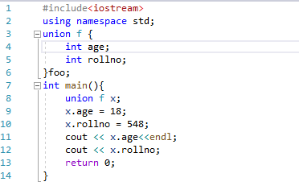

**Output:**

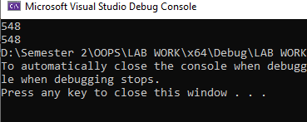

**Problem No. 02:**

**Statement:**

**Classes & Object,Default Constructor,Class Interface**

**Source Code:**

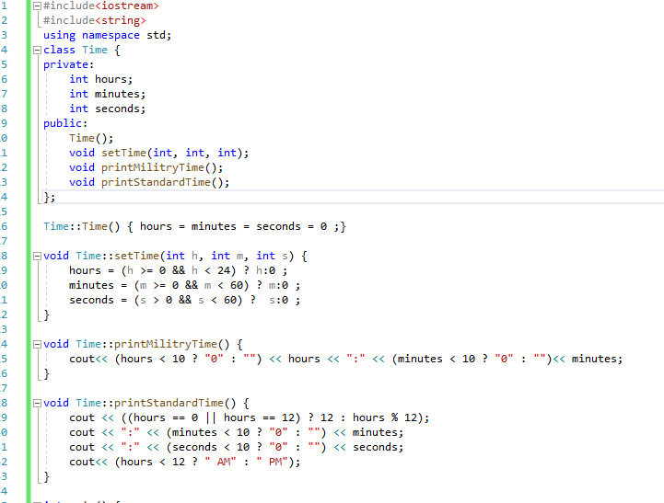

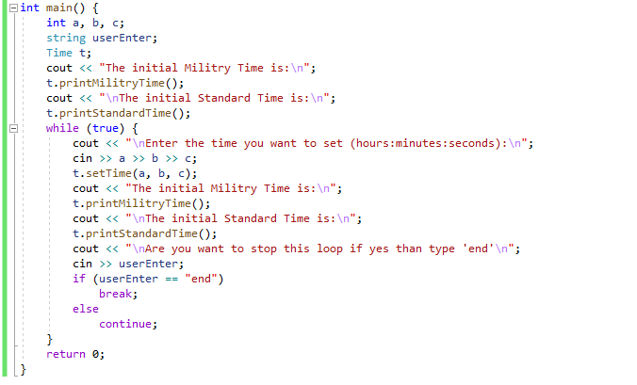

**Output:**

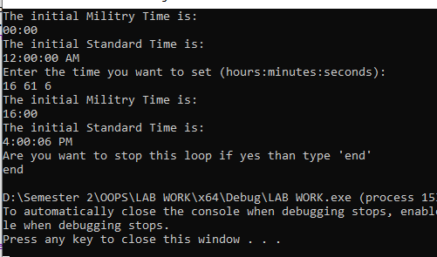

**Problem No. 3:**

**Statement:**

**Separate Interface & Implementation**

**Source code:**

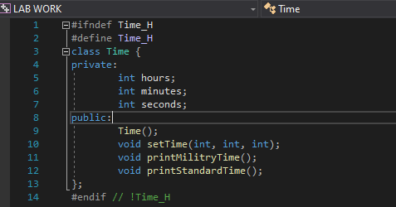

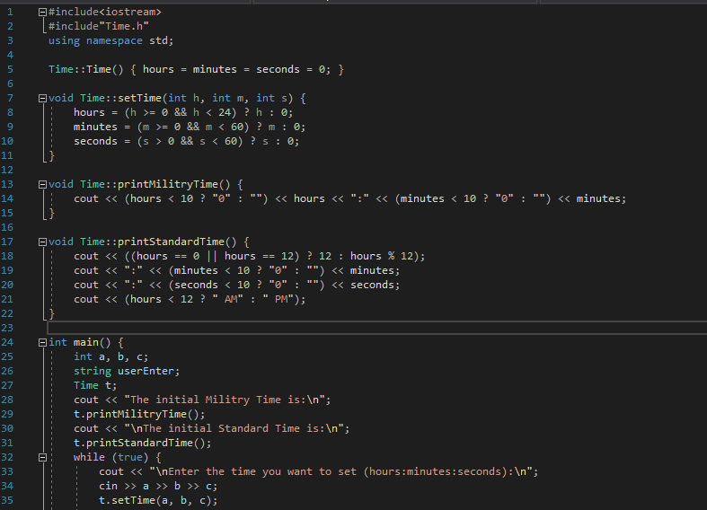

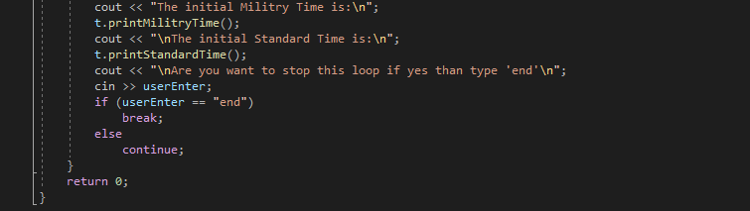

**Output:**

